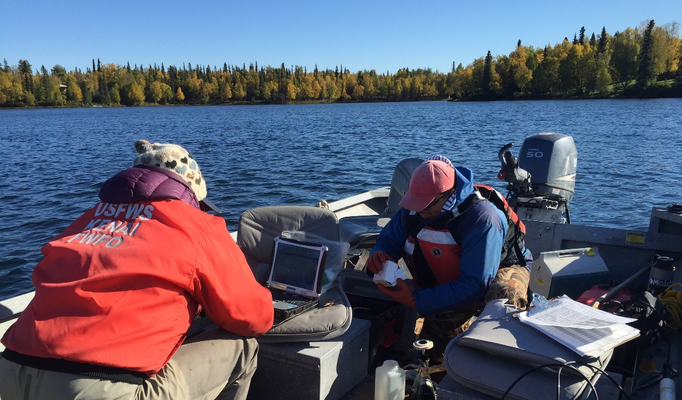

Elodea Eradication & Non-Target Species
Impact Study within the Kenai Peninsula

Kenai Watershed Forum
44129 Sterling Highway
Soldotna, AK 99669
(907) 260-5449
www.kenaiwatershed.org

Project: Eradication of Elodea from the Kenai Peninsula Borough
Document Number: F14AC01270
Reporting Period: May 2014 – December 2018
Report Date: December 27, 2018
Completed By: Jennifer Hester

The purpose of this agreement is to: treat the three infested lakes (Daniels, Stormy and Beck Lake) with aquatic herbicide in order to fully eradicate Elodea canadensis (elodea) from these systems. Treated lakes will be consistently monitored to not only prevent the spread, but to preserve our freshwater ecosystems. Additionally, assistance and technical support will be provided to partners to conduct non-target species impact studies in treated lakes, and new lakes will be surveyed to ensure that no new infestations of elodea occur in the Kenai Peninsula

Goals & Objectives
Attain the objectives & achieve the outcome measures as outlines within the attached project description:
- Determine all locations of elodea on the Kenai Peninsula starting with high priority lakes
- Treat each lake known to contain elodea with fluoridone
- Completely eradicate elodea from the peninsula, protecting salmon & steelhead habitat.

Overview of Work Accomplished During Reporting Period
- In summers 2013 and 2014, staff from the U.S. Fish and Wildlife
Service, Chugach National Forest, Kenai Watershed Forum and the
Homer Soil & Water Conservation District surveyed 101 water bodies
for elodea (Fig. 1). Most of these lakes were at high risk of elodea
introduction because they are surrounded by private landowners, have
a public boat launch, are lakes that have float planes (particularly
commercial charter services), or otherwise are easily accessible from
the highway system. All three are in close proximity to one another
north of the community of Nikiski, and are part of two different but
adjacent watersheds. The 200-acre Beck and 400-acre Stormy Lakes
were heavily infested with elodea and were deemed to require whole lake treatment with herbicides; the 620-acre Daniels Lake was early in its infestation, and treatments were restricted to five discrete embayments (i.e., partial-lake treatment) that totaled 100 acres (Fig 5 & 6). As of Fall 2015 no elodea was detected in Stormy, Beck & Daniels (Fig 8-11).

- In 2016 after Elodea was found during a salmon in the classroom event at Sports Lake, the Kenai Watershed Forum helped organize public meetings, field phone calls and e-mails from the public, worked with ADF&G on the boat launch closure & staffing, and contacted all property owners on Sports Lake. The KWF assisted in pre-treatment surveys that established coverage of the infestation and presence of native species (Fig. 15), clearing of the floating matts of elodea from the west side of the lake (Fig 16), herbicide application to the lake, and in post treatment surveys of elodea and native vegetation. Surveys of all float plane operators on Sports Lake were completed to assist in the creation of a risk assessment map (Fig 12). Sports Lake is a 69.5 acre lake with a mean depth of 10.7 ft and a volume of 743.7 acre-ft. Both Littora Diquat and SonarOne were applied to SportsLake. As of Fall 2018 no elodea was found in Sports Lake after treatments

- In 2017, twenty-five lakes were surveyed for elodea (some of the lakes that are of high risk were re-surveyed). Elodea was detected in two lakes, the North/South lakes that were adjacent to Beck. The KWF wrote permit applications, assisted in suveys and in treatment (Fig. 13)

- This caused concern for these lakes, as well as Sports Lake, had been surveyed in the 2013/2014 round of surveys. Survey methods and protocols in 2016-2018 were more exhaustive and complete, with rake throws occurring at intervals of 25-50 feet and mid-lake transects compared to previously acceptable method of four rake throws per lake in the 2013-2014 surveys. Additionally, a visual inspection of the sediment of a given lake was attained in a perimeter survey of every lake. 2018 seventeen lakes were surveyed with no detection of elodea (Fig 3). The focus of lakes surveyed were ones with high float plane usage, public access, residential and close to the road system. As of Fall 2018, elodea had decreased in the North/South Lakes at 9 of the 50 survey points (18% down from 50%).

- Partners in the Kenai Peninsula Cooperative Weed Management Area, Fairbanks Soil & Water Conservation District, and SePRO subsequently applied two of four-planned herbicide treatments to each of the three lakes infested with Elodea during summer 2014 (Fig.2). Beck and Daniels Lakes were first treated on 3-4 June, the former with the liquid (Sonar Genesis) and pelleted (SonarONE) fluridone (Fig.3), and the latter with diquat bromide and SonarONE, at rates prescribed in the Integrated Pest Management Plan for Eradicating Elodea from the Kenai Peninsula (June 2014). Stormy Lake was similarly treated with Sonar Genesis and SonarONE as prescribed in the IPM, but not until 23 July due to delayed funding. Frequent fluridone monitoring using FasTEST assays indicated that herbicide concentrations in the water column were close to expected in Beck Lake, lower than anticipated in Daniels Lake, and higher than anticipated in Stormy Lake because of a thermocline that developed at ~ 17m. Consequently, when a second treatment of SonarONE was applied to all three lakes on 16-17 September, the application rates were slightly lowered in Beck and Stormy Lakes, and slightly increased in Daniels Lake.

- After the first year of treatment the three infested lakes received two herbicide applications (Summer and Fall of 2014). During early spring of 2015 the three treated lakes were thoroughly surveyed and no traces of elodea were found. We are confident the treatment is working and elodea is being eradicated from the Kenai Peninsula. Further herbicide applications are planned for the summer of 2015 and 2016 depending on the herbicide concentration present in the water column and the presence or absence of Elodea in the lakes. During 2014-2018 multiple monitoring events took in order to increase our level of certainty that Elodea has been eradicated from the Kenai Peninsula.

- Sediment and water samples were sent out for laboratory analysis to look at flouridone and diquat herbicide content (two labs were utilized: Patrick Tomco at University of Alaska Anchorage & EAG laboratories in Easton, Maryland). Results for the sediment came back that the flouridone & diquat were bound to the organic matter in the sediment & inactive. Water samples were quantified with the amount of flouridone present using FasTEST sampling (Fig. 7). Lab work for sediment analysis through Wildlife International LTD from the three treatment lakes in Nikiski. Results from these analyses showed that Diquat was essentially irreversibly bound to soils and sediments and that Fluridone was essentially degraded to the point where it was not detected or in very trace amounts in all samples. Lab results are included below. FasTEST sampling was done for every lake that was treated (Stormy, Beck, Daniels, Sports & the North/South Lakes adjacent to Beck) (Fig. 14). FasTEST samples were done in order to ensure that the fluoridone levels in the water were at the correct concentration (5-6 ppb). The sediment sampling and the entire data set will be used by USFWS biologist John Morton to write a paper on elodea treatments.

- Educational outreach was held as an extension of our Adopt-A-Stream program. An invasive species interactive presentation was given, in which students from Kalifornsky Beach Elementary School, Soldotna Middle School, Soldotna Montessori, Tustumena, Nikiski North Star and Kaleidoscope School learned about the threat of harm elodea poses to Alaska’s salmon population, recreational opportunities and ecosystem. Additional educational outreach was done at ADF&G’s Salmon Celebration. Students were given the change to throw the rake & ID native plants. Elodea and other invasives were discussed with the students.
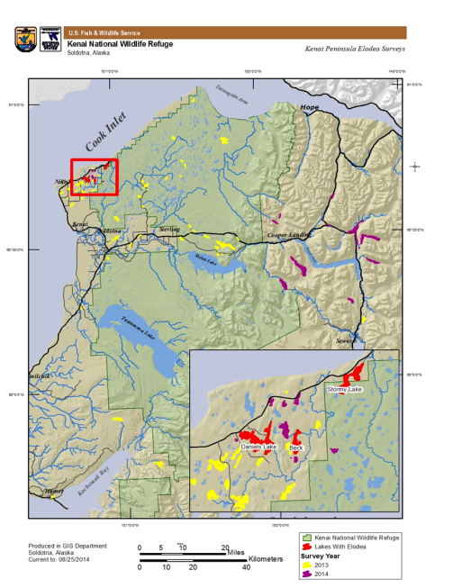

Figure 1. Lakes that were surveyed in 2013-2014
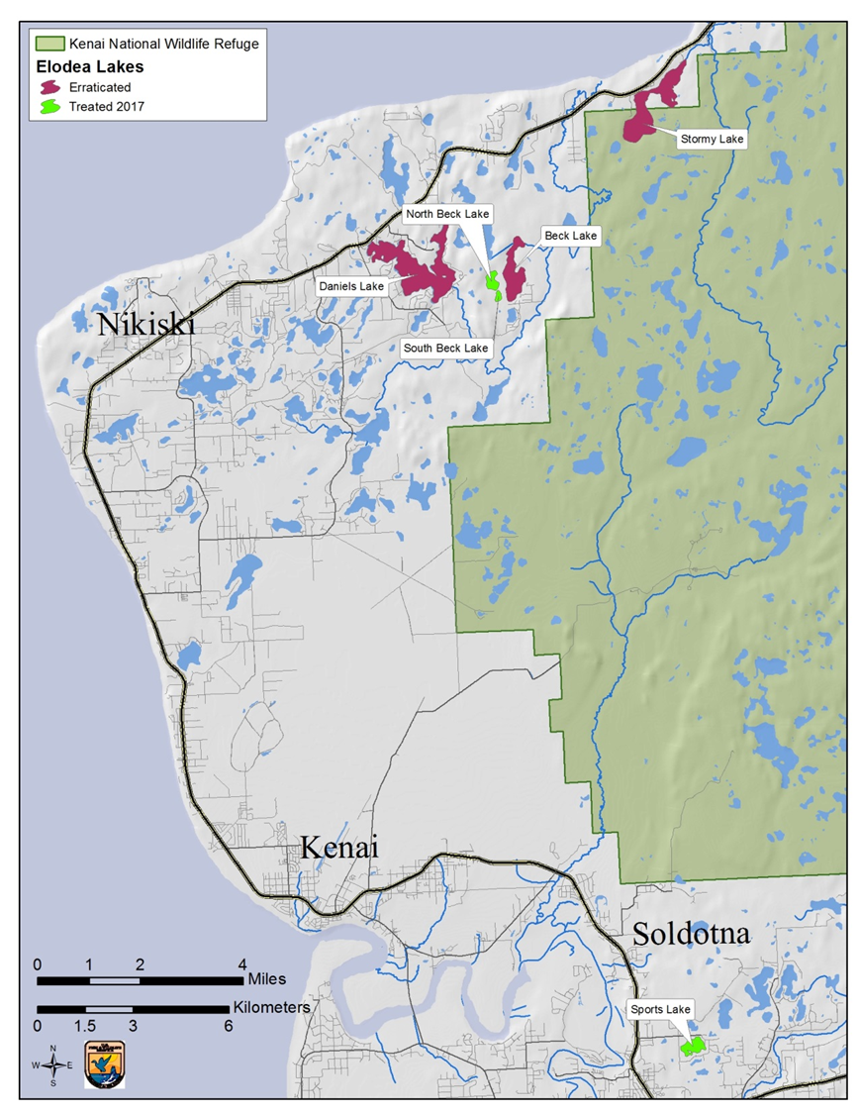
Figure 2. Lakes that have had elodea present on the Kenai Peninsula.
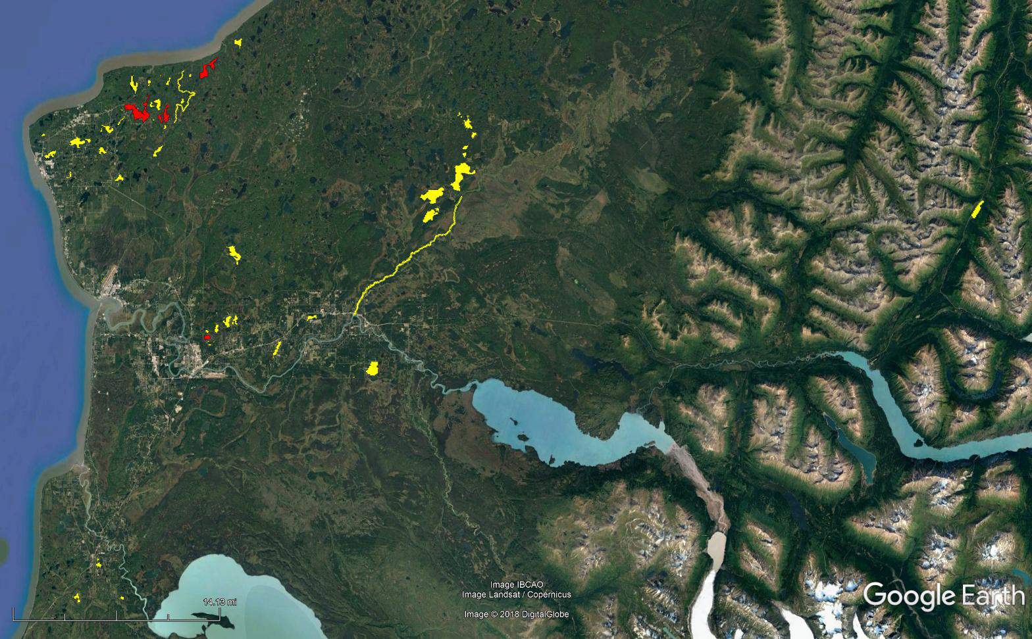
Figure 3. Lakes that were surveyed in 2017-2018

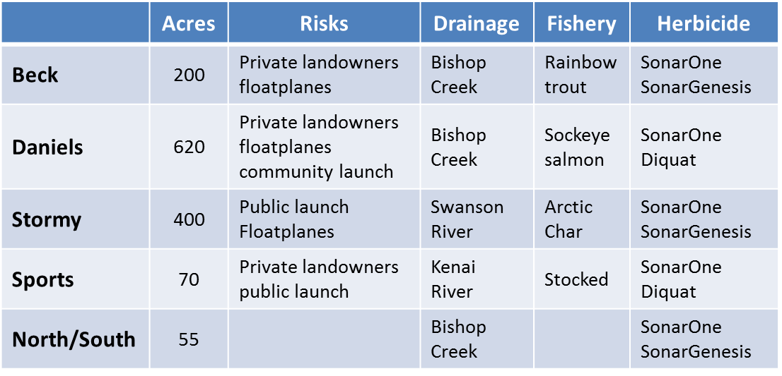
Figure 4. Elodea infested lakes on the Kenai Peninsula.
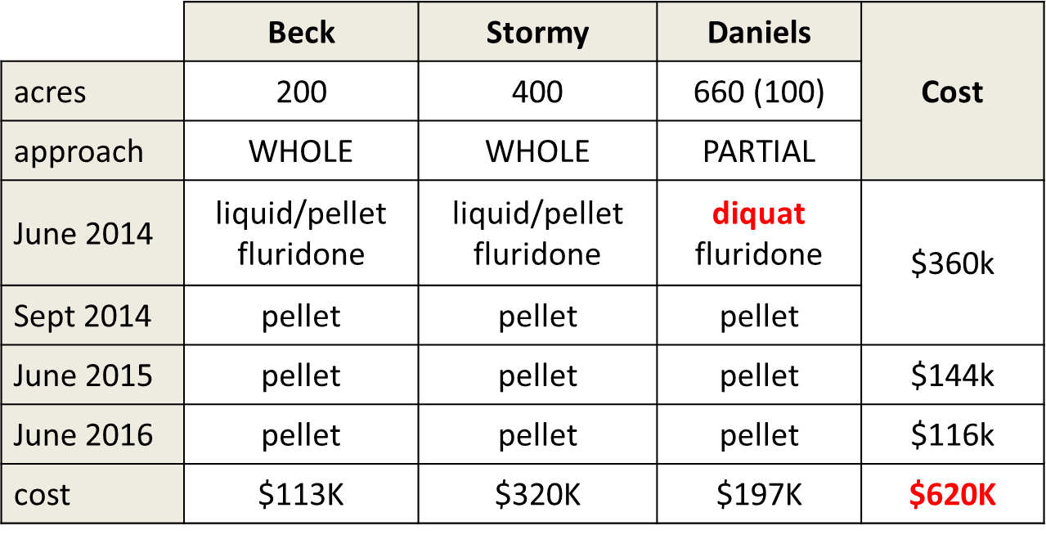
Figure 5. Prescribed: 4 herbicide treatments over 3 year (2014-2016) to eradicate elodea in Stormy, Beck & Daniels Lakes
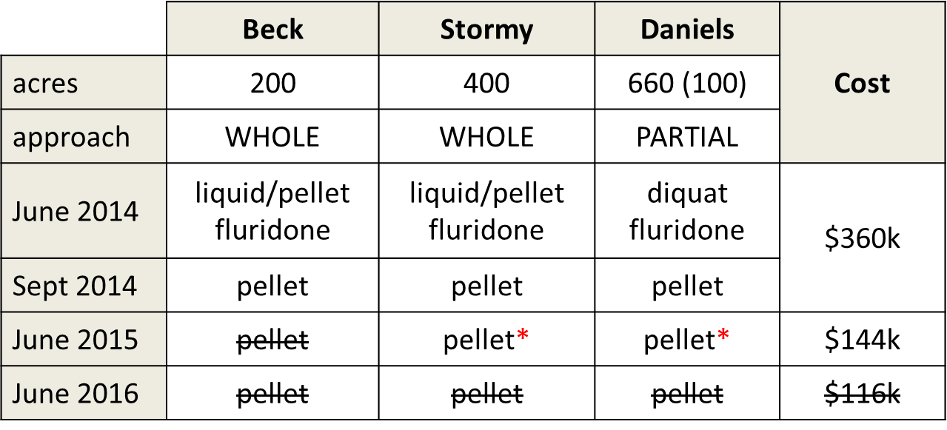
Figure 6. Actual: 2+ herbicide treatments over 2 years (2014-2015) to eradicate elodea in Stormy, Beck & Daniels Lakes.
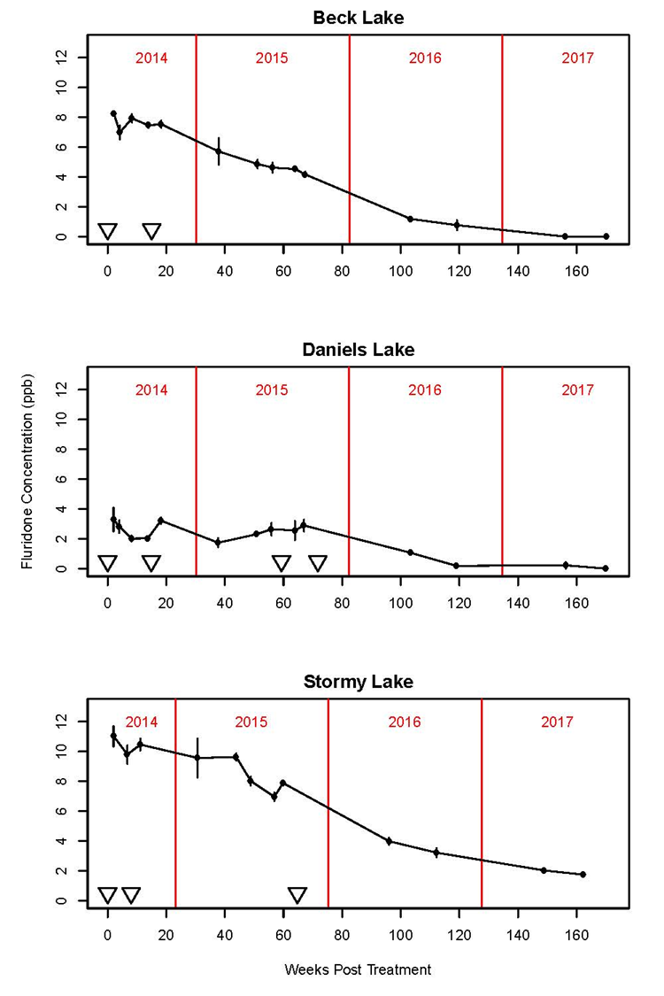
Figure 7. The fluridone FasTEST sample results. 1st application to Beck & Daniels on June 3rd & 4th 2014, to Stormy on July 23, 2014 2nd application to Beck, Daniels & Stormy onSeptember 16th-17th, 2014; 3rd application to Daniels on July 24, 2015; 4th application to Daniels on October 19, 2015.

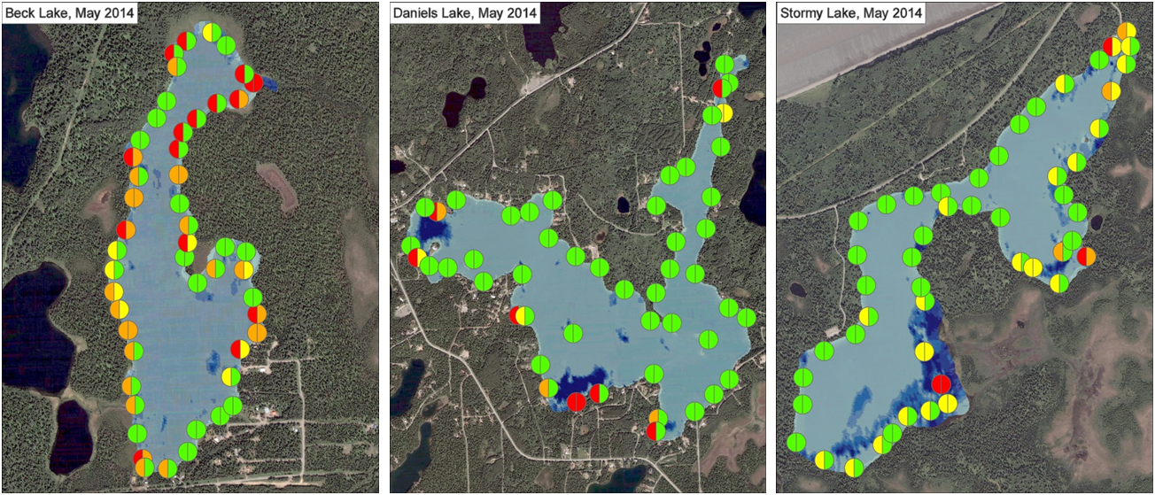
Figure 8. 50 point survey results of elodea presence/abundance in 2014 on Beck, Daniels & Stormy Lakes (USFWS).

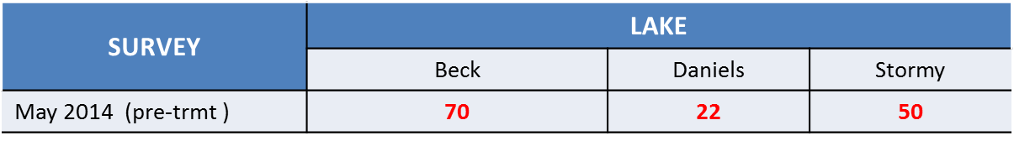
Figure 9. 50 point survey results of elodea in Beck, Daniels & Stormy to estimate percentage of elodea infestation of the lake (USFWS).
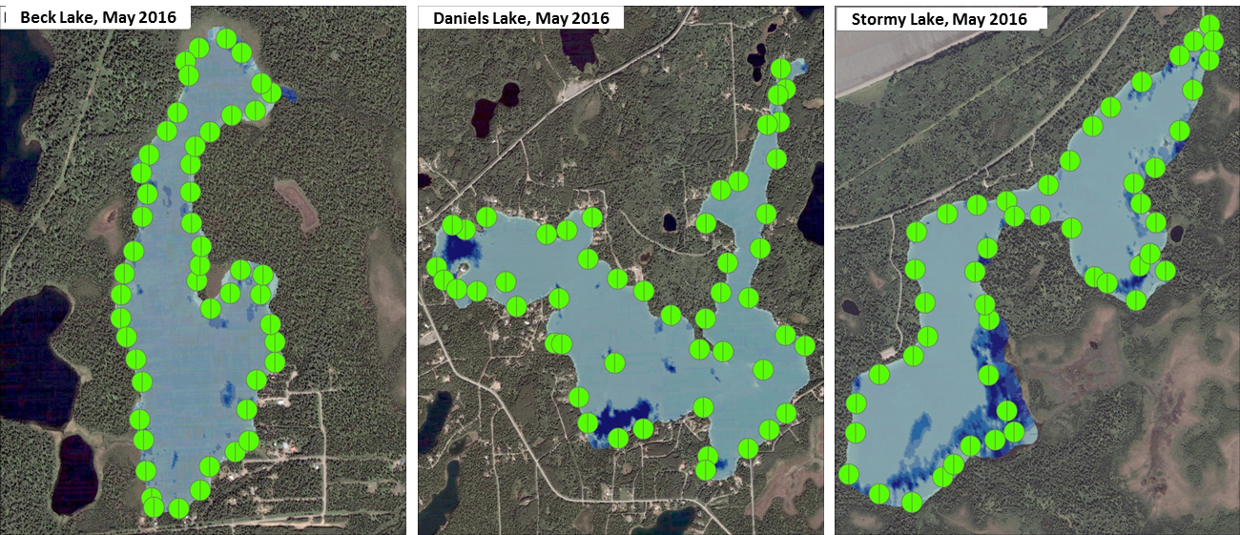 Figure 10. 50 point survey results of elodea presence/abundance in 2016 on Beck, Daniels & Stormy Lakes (USFWS).

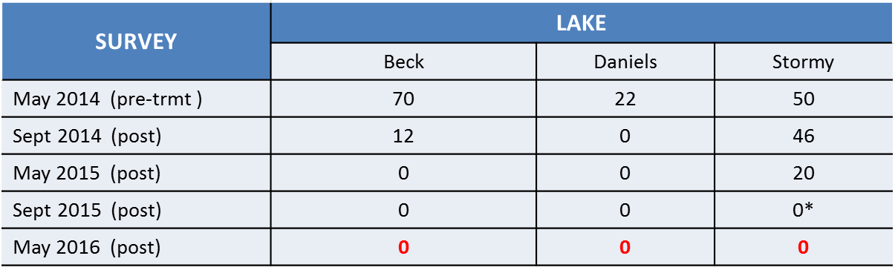
Figure 11. 50 point survey results of elodea in Beck, Daniels & Stormy to estimate percentage of elodea infestation of the lake (USFWS).

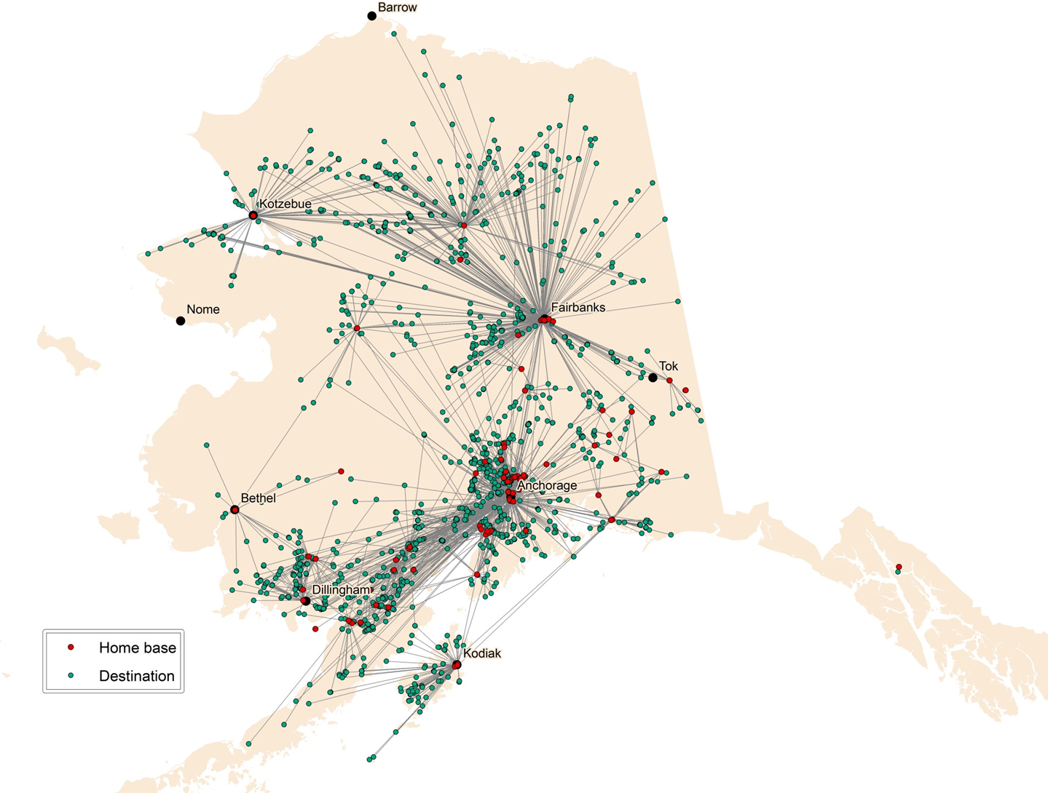
Figure 12. Map by Tobias Schworer (UAF) of Floatplane destinations for elodea transportation risk. Sports Lake float plane operators were interviewed to assist in the creation of this map. (UAF)
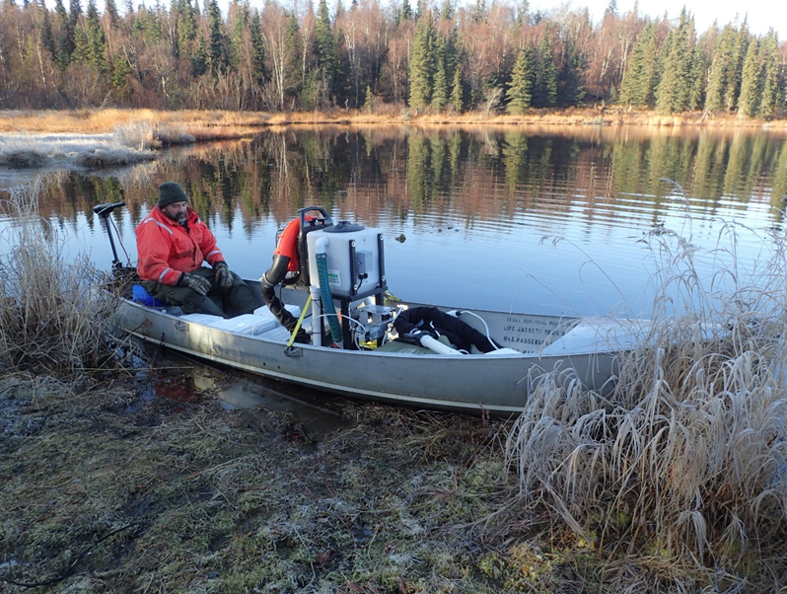
Figure 13. Kenai National Wildlife Regure Biologist, Todd Eskelin, applying the treatment of the North/South Lakes with fluridone (2017).
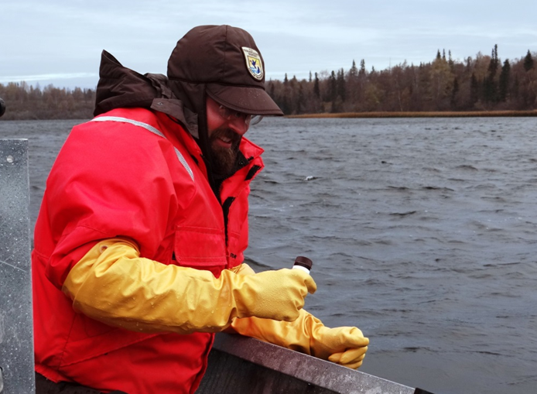
Figure 14. Kenai National Wildlife Entimolost, Matt Bowser, taking a FasTEST sample in Stormy Lake (2016).
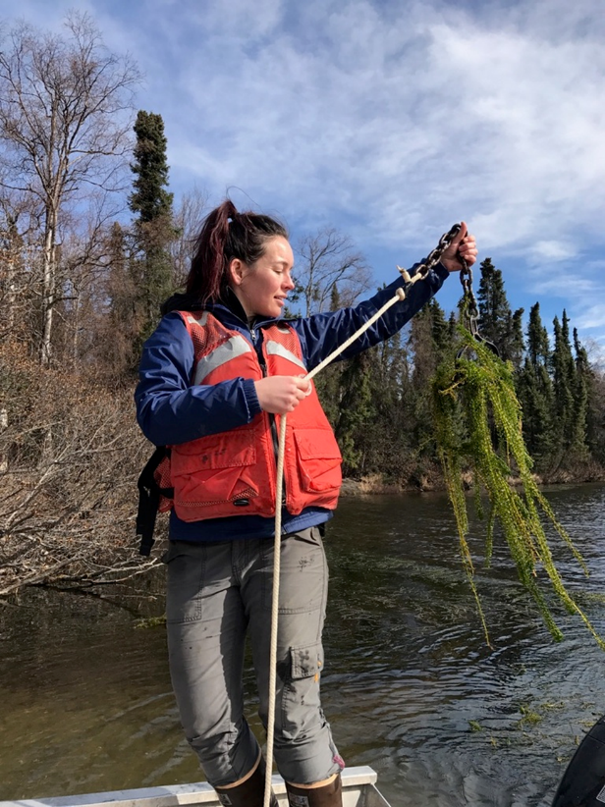
Figure 15. Kenai Watershed Forum biologist, Jennifer Hester, surveying Sports Lake for elodea.
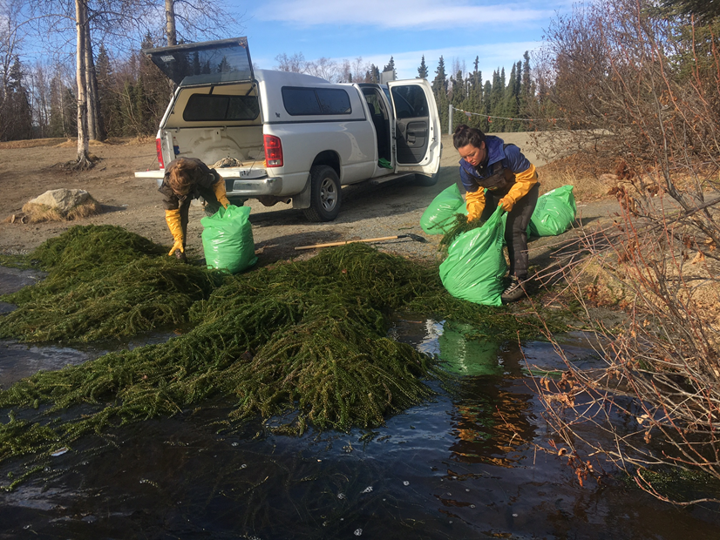
Figure 16. Removing elodea from the boat launch at Sports Lake to reduce the risk of spread via trailer boats.
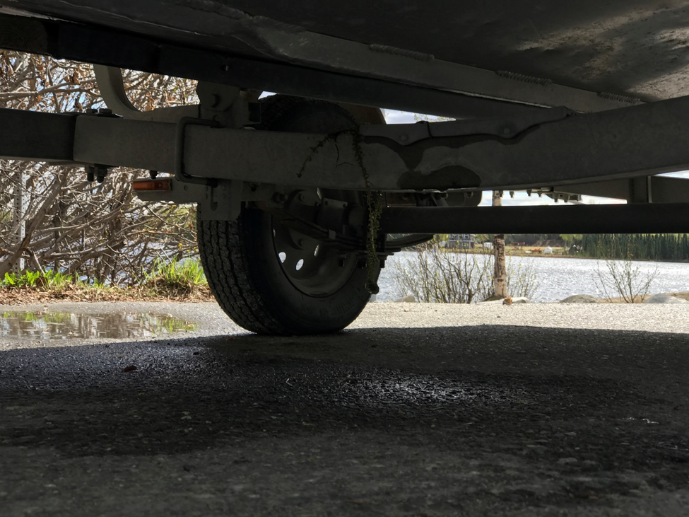
Figure 17. Elodea on the USFWS trailer after pulling out from the launch.

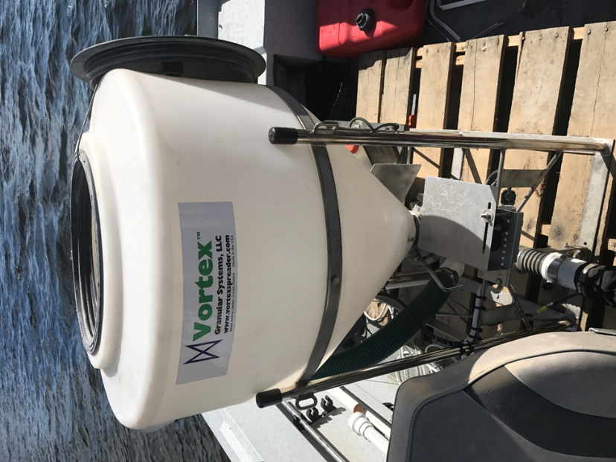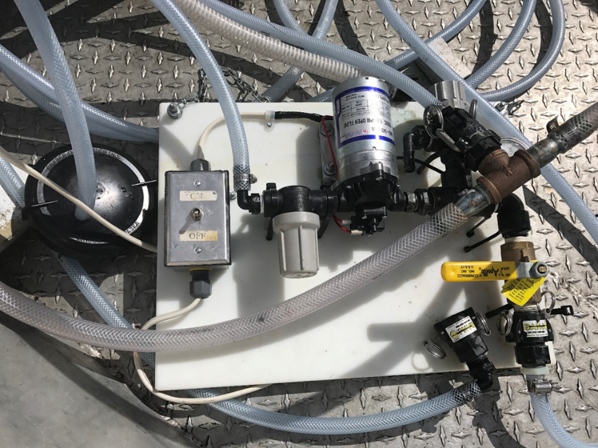
Figure 18. The Vortex spreader and controls that apply fluridone pellets. Sports Lake 2017.
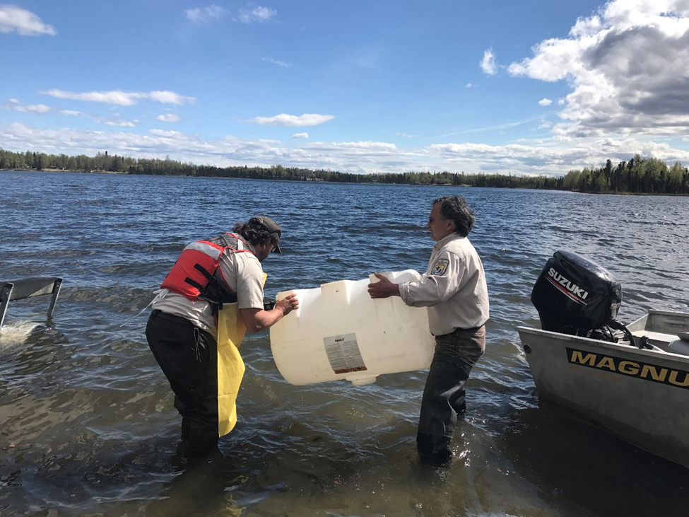
Figure 19. Refuge biologists Todd Eskelin & John Morton rinsing the diquat tank post treatment.
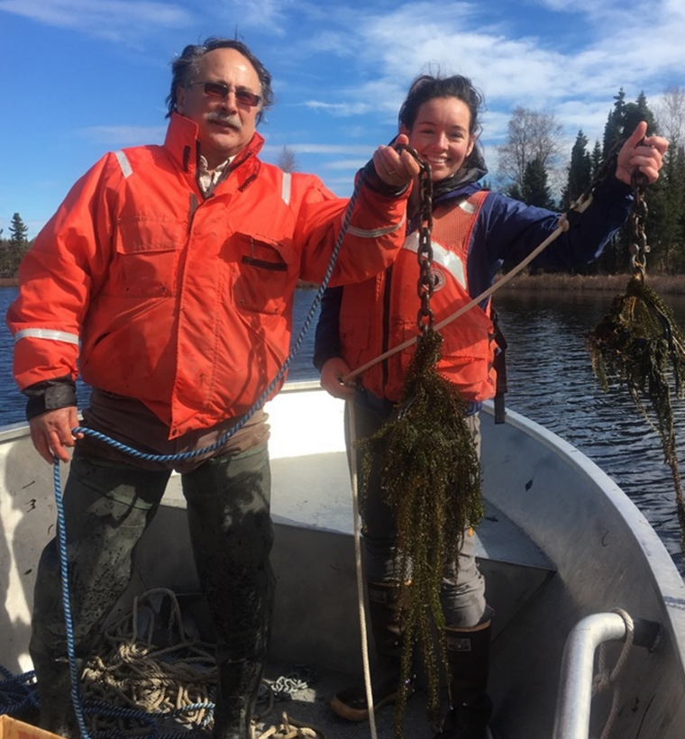
Figure 20. Refuge biologist John Morton & KWF biologist, Jen Hester, surveying Sports Lake (2017).

Sediment Analysis results:
Wildlife International, Evans Analytical Group
Project #: 785C-102
Client: Kenai Watershed Forum
Analyte: Fluridone
Matrix: Sediment

Sediment samples provided by Kenai Watershed Forum were analyzed for residues of fluridone by high performance liquid chromatography with ultraviolet absorbance detection (HPLV/UV) following extraction of the samples with 50:50 (v/v) acetonitrile : HPLC grade water. The samples were sonic disrupted for 5-10 minutes and centrifuged at ~12000 x g prior to analysis.
Sample ID |  | Amount Detected
 |  | (ppm)
S1 |  | ND
S1 |  | ND
S2 |  | ND
S2 |  | ND
S3 |  | 0.0329 | *
S4 |  | ND
S4 |  | ND
S6 |  | 0.0239 | *
D1 |  | ND
D1 |  | ND
D3 |  | 0.0144 | *
D6 |  | ND
D6 |  | ND
D9 |  | 0.0368 | *
D15 |  | 0.0114 | *
B1 |  | 0.0124 | *
B2 |  | 0.0286 | *
B3 |  | 0.0138 | *
B4 |  | 0.0210 | *
B6 |  | 0.0137 | *
* extrapolated value; reported value is less than the limit of quantitation
LOQ = 0.0500 ppm

Page 1 of 3
Project # 785C-101-Diquat
Sediment Install
Test Concentrations
0.100 And 10.0 ppm a.i.

Diquat Analysis summary
Samples were extracted and analyzed by using following procedures:

Trial # 1

Prepare Diquat calibration standards in 50:50: (HPLC grade water: (1:1 methanol: 0.1M HCL)) using Class A volumetric flasks and gas-tight syringes or equivalent.
Weigh 2.00 grams of sediment into scintillation vial.
Fortify recovery samples with appropriate diquat stock solutions. Unfortified sediment will serve as the matrix blank. HPLC water will serve as reagent blank.
Volumetrically add 10.0 mL of HPLC grade water to each scintillation vial then volumetrically add 10.0 mL (1:1 methanol: 0.1M HCL).
Shake the samples on auto vortexer at top speed for approximately 5 minutes.
Heat the samples for 15 min at 80 degree Celsius.
As needed, make dilutions using 50:50: (HPLC grade water: (1:1 methanol: 0.1M HCL))
using class A volumetric flasks and gas-tight syringes or equivalent.
Filter the extracts using 0.45 um Teflon syringe filter

Samples extracts weren’t analyzed due to LCMS issues.

Trial # 2

Prepare Diquat calibration standards in 0.1M HCL using Class A volumetric flasks and gas-tight syringes or equivalent.
Weigh 2.00 grams of sediment into plastic centrifuge tube. Fortify recovery samples with appropriate diquat stock solutions. Unfortified sediment will serve as the matrix blank. HPLC water will serve as reagent blank.
Volumetrically add 10.0 mL 0.1M HCL using Class A volumetric pipette to each sample then Sonic disrupt for 10 min at 30%. Centrifuge at 491 RCF (g) for 5 minutes and transfer each centrifuged extract into pre label 50 ml graduate plastic tube.
Volumetrically add 10.0 mL 0.1M HCL using Class A volumetric pipette to each sample again for second extraction. Sonic disrupt for 10 min at 30%. Centrifuge at 491 RCF (g) for 5 minutes. Transfer each extract into pre label appropriate 50 ml graduate plastic tube. Bring final volume to 20.0 mL mark as necessary with 0.1M HCL.
As needed, make dilutions using 0.1M HCL using class A volumetric flasks and gas-tight syringes or equivalent.
Filter the extracts using 0.45 um Teflon syringe filter

No diquat was detected for sediments extracts.

Trial # 3

Prepare Diquat calibration standards in HPLC grade water using Class A volumetric flasks and gas-tight syringes or equivalent.
Weigh 2.00 grams of sediment into a 50 mL round bottom flask. Fortify recovery samples with appropriate diquat stock solutions. Unfortified sediment will serve as the matrix blank. HPLC water will serve as reagent blank.

Add 15 mL 2M H₂SO₄ using graduated cylinder or equivalent to each sample then reflux samples for 2 hours. Filter sample extracts into pre-labeled 50 ml graduated plastic tubes using glass funnel and filter paper. Bring final volume up to 20.0 mL mark as necessary using 2M H₂SO₄.

As needed, make dilutions in HPLC grade water using class A volumetric flasks and gas-tight syringes or equivalent.

No diquat was detected for low treatment. For high level treatment, the recoveries were 21.9-24.7% of nominal.

Trial # 4

Prepare Diquat calibration standards in HPLC grade water using Class A volumetric flasks and gas-tight syringes or equivalent.
Weigh 2.00 grams of sediment into a 50 mL round bottom flask. Fortify recovery samples with appropriate diquat stock solutions. Unfortified sediment will serve as the matrix blank. HPLC water will serve as reagent blank.

Add 15 mL 2M H₂SO₄ using graduated cylinder or equivalent to each sample then reflux samples for 4 hours. Filter sample extracts into pre-labeled 50 ml graduated plastic tubes using glass funnel and filter paper. Bring final volume up to 20.0 mL mark as necessary using 2M H₂SO₄.

As needed, make dilutions in HPLC grade water using class A volumetric flasks and gas-tight syringes or equivalent.

No diquat was detected for low treatment.
For high level (10 ppm a.i) Rep. A and B has 14.2 and 10.5 % nominal respectively. No peak was detected for Rep. C.

Trial # 5

Prepare Diquat calibration standards in HPLC grade water using Class A volumetric flasks and gas-tight syringes or equivalent.
Turn on reflux condenser and heating mantle an hour prior to refluxing the samples.
Weigh 2.00 grams of sediment into a 125 mL round bottom flask. Fortify recovery samples with appropriate diquat stock solutions. Unfortified sediment will serve as the matrix blank. HPLC water will serve as reagent blank.

Add 25 mL 2M H₂SO₄ using graduated cylinder or equivalent to each sample then reflux samples for 4 hours.

Once refluxing has started, check on the samples periodically. Adjust the temperature so that bubbling is steady and uniform.

Once refluxing is complete, allow samples to cool down. Transfer samples into a pre-labeled 50 mL propylene tubes. Adjust volume to 40 mL mark by rinsing the inside of the condenser and round bottom flask with HPLC H₂O.

Centrifuge samples at 3000 rpm for 10 minutes and transfer extracts into a new pre-labeled 50 mL propylene tubes.

As needed, make dilutions in HPLC grade water using plastic tube and eppendorf pipette.

No diquat was detected for low treatment.
For high level (10 ppm a.i) <LOQ all extrapolated value.

Trial # 6

Prepare Diquat calibration standards in HPLC grade water using Class A volumetric flasks and gas-tight syringes or equivalent.
Turn on reflux condenser and heating mantle an hour prior to refluxing the samples.
Weigh 2.00 grams of sediment into a 125 mL round bottom flask. Fortify recovery samples with appropriate diquat stock solutions. Unfortified sediment will serve as the matrix blank. HPLC water will serve as reagent blank.

Add 25 mL 9M H₂SO₄ using graduated cylinder or equivalent to each sample then reflux samples for 4 hours.

Once refluxing has started, check on the samples periodically. Adjust the temperature so that bubbling is steady and uniform.

Once refluxing is complete, allow samples to cool down. Transfer samples into a pre-labeled 50 mL propylene tubes. Adjust volume to 40 mL mark by rinsing the inside of the condenser and round bottom flask with HPLC H₂O.

Centrifuge samples at 3000 rpm for 10 minutes and transfer extracts into a new pre-labeled 50 mL propylene tubes.

As needed, make dilutions in HPLC grade water using plastic tube and eppendorf pipette.

The recoveries for low treatment were 23.0 to 25.5 % of nominal and for high treatment the recoveries were 25.3 to 27.7% of nominal. All are extrapolated value.

