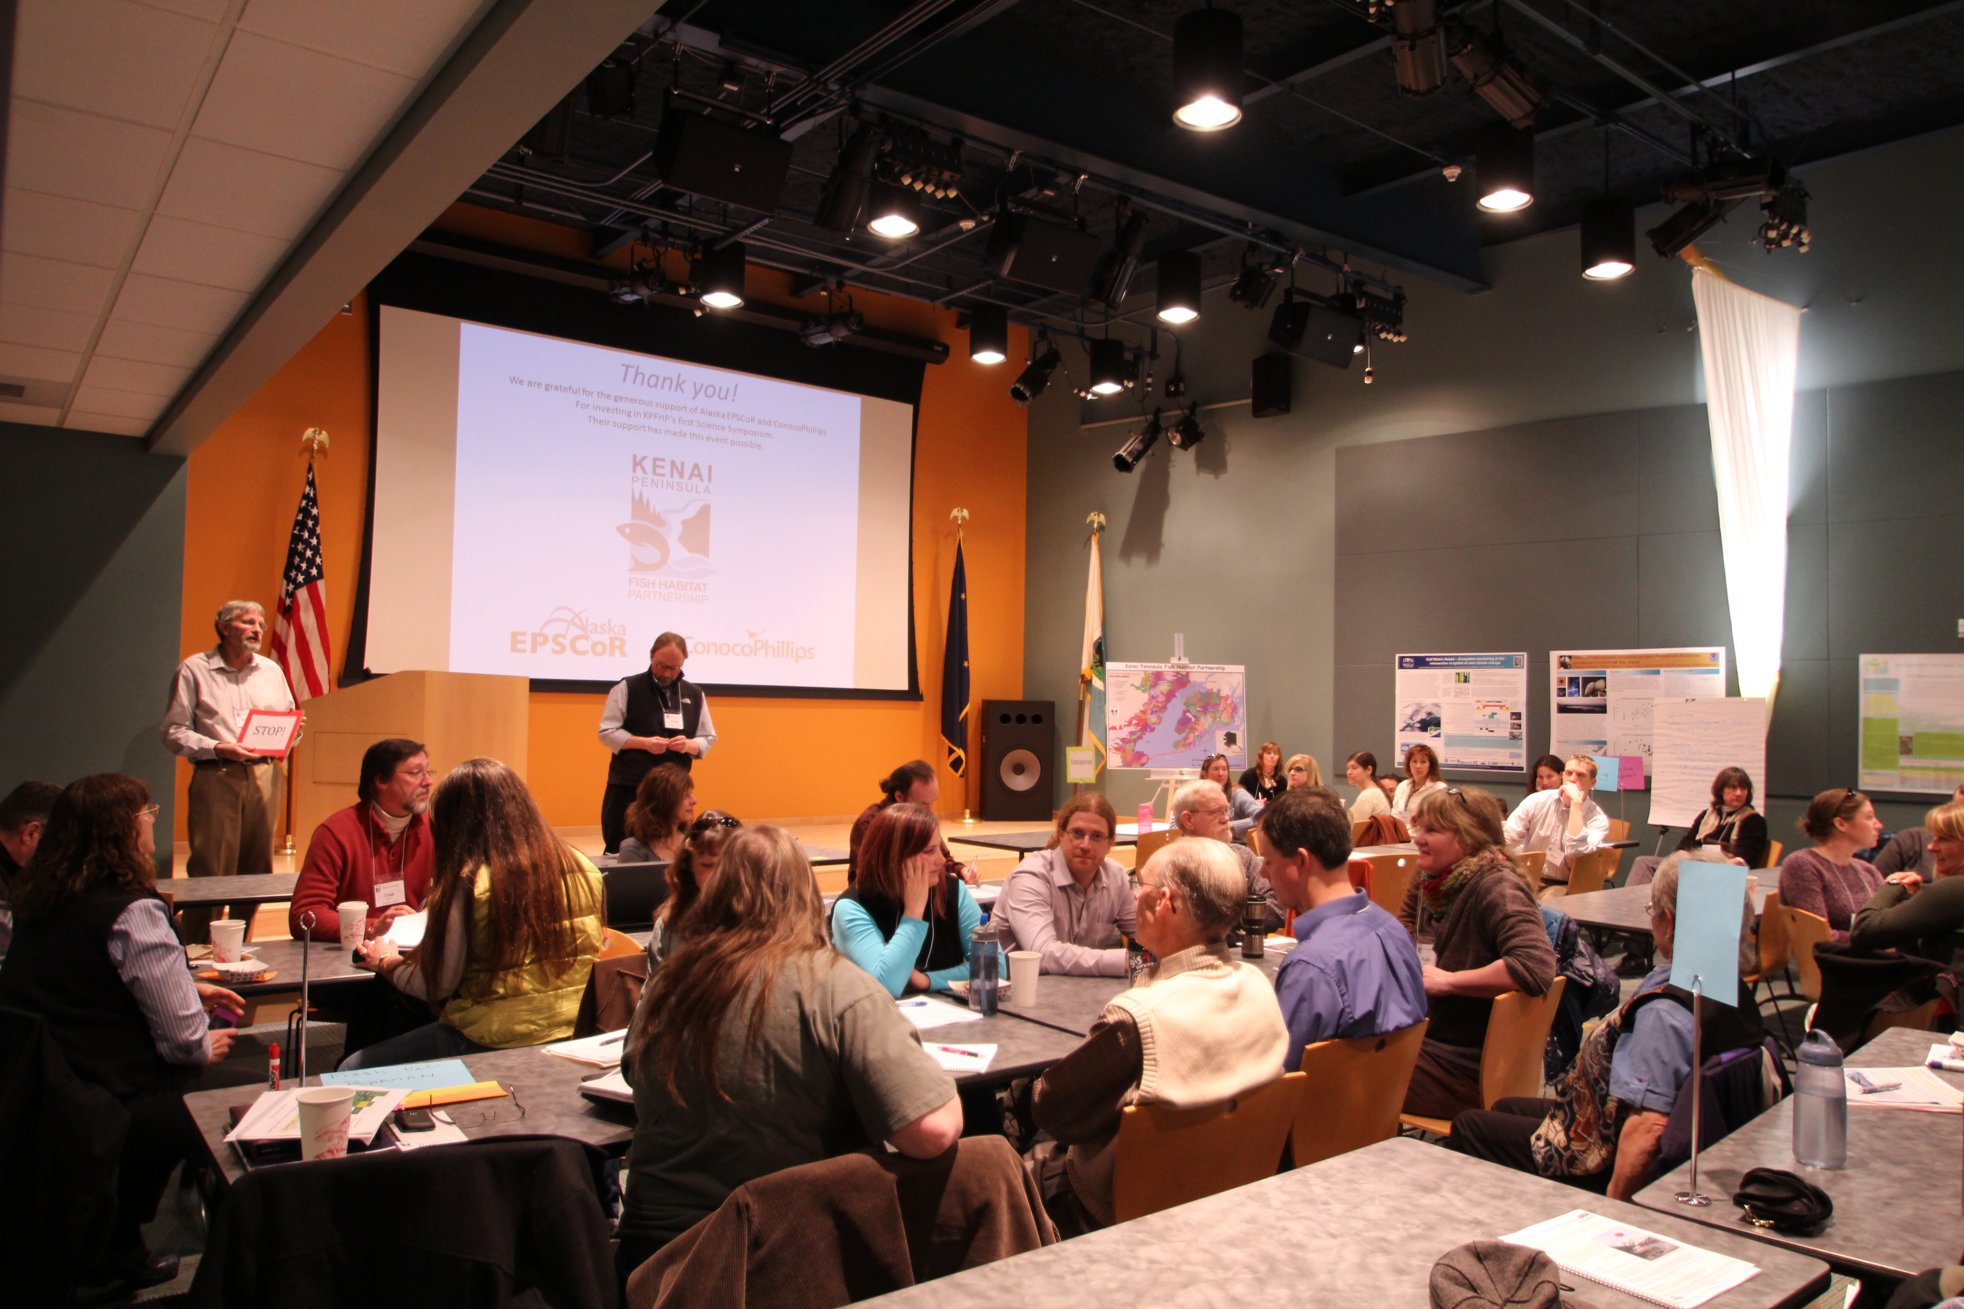

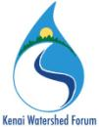

Kenai Peninsula Fish Habitat Partnership Strategic Habitat Action Plan

**Kenai Watershed Forum**

44129 Sterling Highway

Soldotna, AK 99669 USA

+1.907.260.5449

www.kenaiwatershed.org

**Project:** Kenai Peninsula Fish Habitat Partnership Strategic Habitat Action Plan

**December**

**2013**

**Final Project Report**

**Document Number:** F11AC00577

**Report Date**: 5 December 2013

**Completed By**: Rebecca Zulueta, Environmental Specialist

Funds under this cooperative agreement award were used to: provide coordination and implementation of the Kenai Peninsula Fish Habitat Partnership strategic habitat planning effort to implement the objectives of the Partnership’s strategic plan.

**Background**

Increased population growth, unregulated development, habitat fragmentation, degraded water quality, loss of water quantity, and climate change, and are all threats faced by fish habitat in the Kenai Peninsula. Partnership members and other stakeholders are challenged by these threats as they work towards maintaining healthy fish habitat that supports self-sustaining fish populations. The Kenai Peninsula Fish Habitat Partnership is continuing to work together to address habitat needs of freshwater and marine fish species that reside in the waters of the Kenai Peninsula Borough at some point in their lifecycle. The Partnership has taken a strategic approach to protecting healthy aquatic systems while working to restore degraded systems in support of the National Fish Habitat Action Plan through drafting a strategic action plan that identifies the partnership, biological complexity, water quality and quantity, science and technology, education and policy as the highest priority areas to focus its efforts.

**Goals and Objectives**

1. Conduct scoping meeting with TNC and KPFHP Steering Committee
2. Implement CAP process
   1. Identify project and people
   2. Define conservation targets
   3. Assess viability of conservation targets
   4. Identify critical threats
   5. Conduct situation analysis
3. Provide progress report and give presentation to Kenai Peninsula Fish Habitat Partnership Steering Committee
4. Draft Action Plan report to Steering Committee
5. Final Action Plan presented to Steering Committee
6. Submit Final Report to Service and close out agreement

**Overview**

The Kenai Watershed Forum (KWF), has worked closely with the FWS Program officer to carry out a total of three separate two-day meetings to develop a Conservation Action Plan (CAP) for the Kenai Peninsula Fish Habitat Partnership (KPFHP). The CAP has been assisted greatly by Greg Low of Applied Conservation. Greg was hired on to facilitate the meeting of 16 scientist team members. Meetings were held in May, September and November of 2012. All of the following milestones have been completed:

* Identify project scope and people (16 scientists)
* Define our Conservation targets (identified in figure 1)
* Assess the viability of selected conservation targets
* Identified potential critical threats
* Identified strategies
* Completed a situational/ capacity assessment to abate potential threats

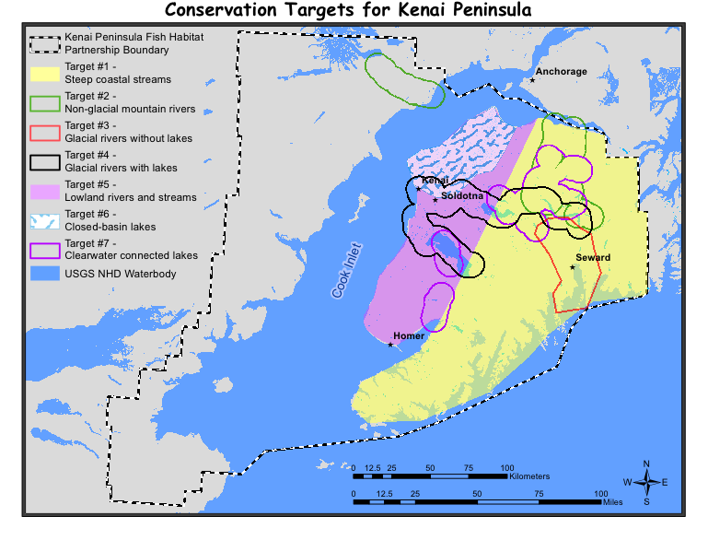

**Figure 1.** Map of the Kenai Peninsula including seven target areas developed for the KPFHP CAP.

In addition to the science team developing the CAP, the KPFHP Steering Committee has had regular updates on the progress of the CAP by both the KWF and the FWS Project Officer. A draft of the CAP for presentation to the Steering committee was completed during the spring of 2013.

In order to gain more input about targets and threats for the CAP development from local scientists outside of the KPFHP, a round table discussion was held during the 2013 KPFHP Science Symposium. Participants were asked to give input on various categories while in groups, after which many comments were noted and used for the final plan. The Final Plan was completed during the fall of 2013.

The Final Plan can be found on the Kenai Peninsula Fish Habitat Partnership’s website at: <http://www.kenaifishpartnership.org/?page_id=303>

This includes both the Freshwater and Marine plans.

In summary, the highest critical threats determined through the CAP process are:

Freshwater

1. Injurious invasive aquatic species (present and potential species)
2. Warmer climate
3. Incompatible road development
4. Residential development in riparian zones

Marine

1. Large scale oil spill- petroleum discharge (oil/gas)
2. Incompatible shoreline development
3. Beach armoring