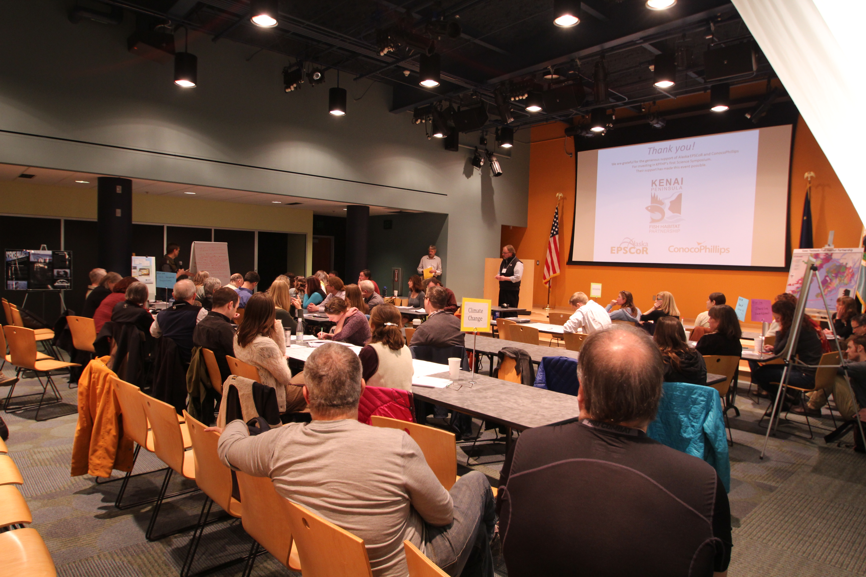

Kenai Peninsula Fish Habitat Partnership Science Symposium
Kenai Watershed Forum

44129 Sterling Highway
Soldotna, AK 99669 USA
+1.907.260.5449
www.kenaiwatershed.org

Project: Kenai Peninsula Fish Habitat Partnership Science Symposium
December
2013
Final Project Report
Document Number: F12AC01609
Report Date: 5 December 2013
Completed By: Rebecca Zulueta, Environmental Specialist

Funds under this cooperative agreement award were used to: hold a fish habitat science symposium, modeled after the adjacent Mat-Su Salmon Partnership’s symposiums of recent years to share information on conservation and research projects related to the Kenai Peninsula Fish Habitat Partnership’s strategic plan, as authorized by the Fish & Wildlife Coordination Act, 16 USC 661 to 666C; and Fish and Wildlife Act of 1956, as amended, 16 U.S.C. 742a-742j.

Goals and Objectives
A. Coordinate the development of an Agenda, Format, & Content for a 2-day Science Symposium
B. Coordinate logistics for 2-day Science Symposium
C. Host 2-day Science Symposium
D. Develop, distribute, and collate responses from a post-symposium survey
E. Produce overview and synopsis of Symposium and Survey results

Overview of Science Symposium
The Kenai Peninsula Fish Habitat Partnership hosted its first Science Symposium on April 17th and 18th of 2013 at the Islands and Ocean Visitor Center in Homer, Alaska, with the help of the Kenai Watershed Forum staff and it’s many other partners.

The Science Symposium brought together a myriad of people concerned with fish habitat and offered opportunities to interact with researchers, habitat advocates and the general public. Over 75 people attended the first day and more than 60 the second day. The symposium facilitated communication on up-to-date research, as well as encouraged idea exchange for more effective management. Through scheduled networking and the “Meet, Greet, and Eat”, the symposium increased connections between scientists and researchers across the peninsula and beyond.

Synopsis
To start off the Science Symposium the Kenai Peninsula Borough Mayor, Mike Navarre was welcomed to speak. He graciously accepted and talked about the importance of fish habitat science on the Kenai Peninsula (Figure 1).
Figure 1. Kenai Peninsula Borough Mayor Mike Navarre welcomes all attendees to the first Kenai Peninsula Fish Habitat Partnership Science Symposium.

Our keynote speaker for the symposium was Randy Olson, a scientist turned filmmaker (Figure 2). Today, Olson is a communications consultant to organizations including the CDC, NASA, and the National Institute of Health. At the symposium, Olson hosted a small workshop the first afternoon and then gave an evening talk, which was widely publicized to the general public. The next morning he also held a question and answer session. Olson’s talk of linking science to a human element seemed to resonate with many attendees.

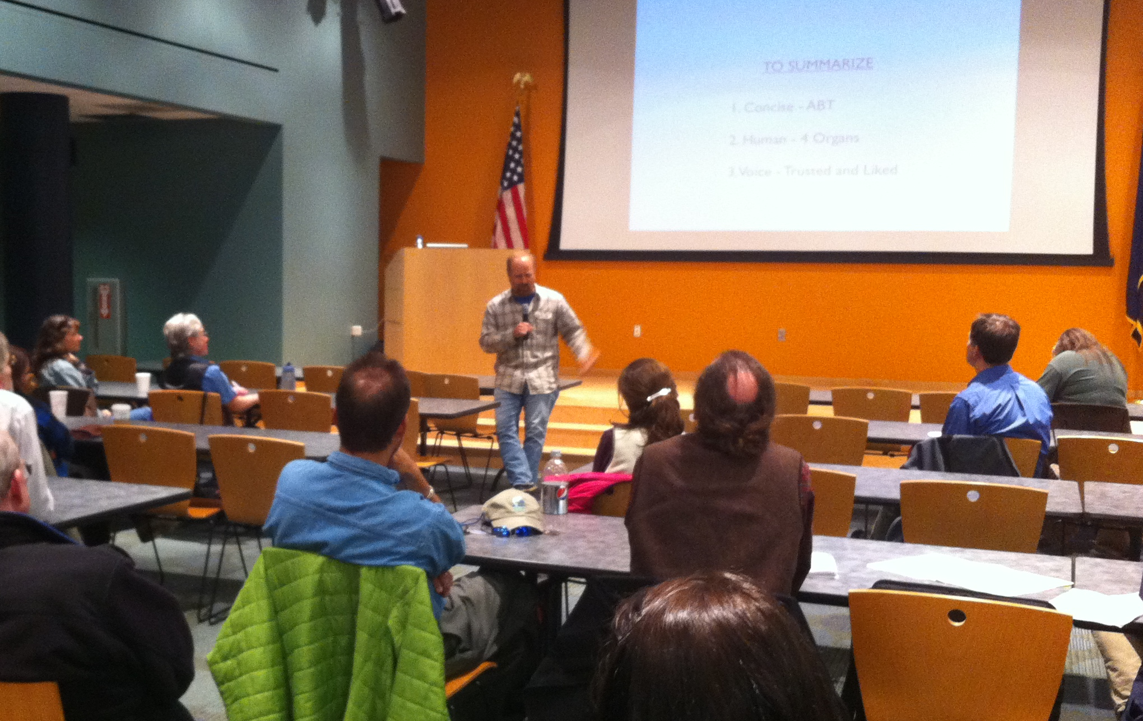
Figure 2. Keynote speaker Randy Olson shares stories of communicating science at the first Kenai Peninsula Fish Habitat Partnership Science Symposium.

The Science Symposium hosted 17 scientist presentations greatly ranging in topics such as peatland contributions to stream flow, collaborative approaches for hydrological datasets, and the wintering ecology of juvenile Coho salmon (Figure 3). There was also a poster session including 10 posters with topics such as ecosystem monitoring, the history of land use on the Kenai River, and influence of estuaries on expression of juvenile life history in Coho salmon. These formats allowed information sharing across the various disciplines and agencies involved in fish habitat. All presentations are available on the KPFHP website at: http://www.kenaifishpartnership.org

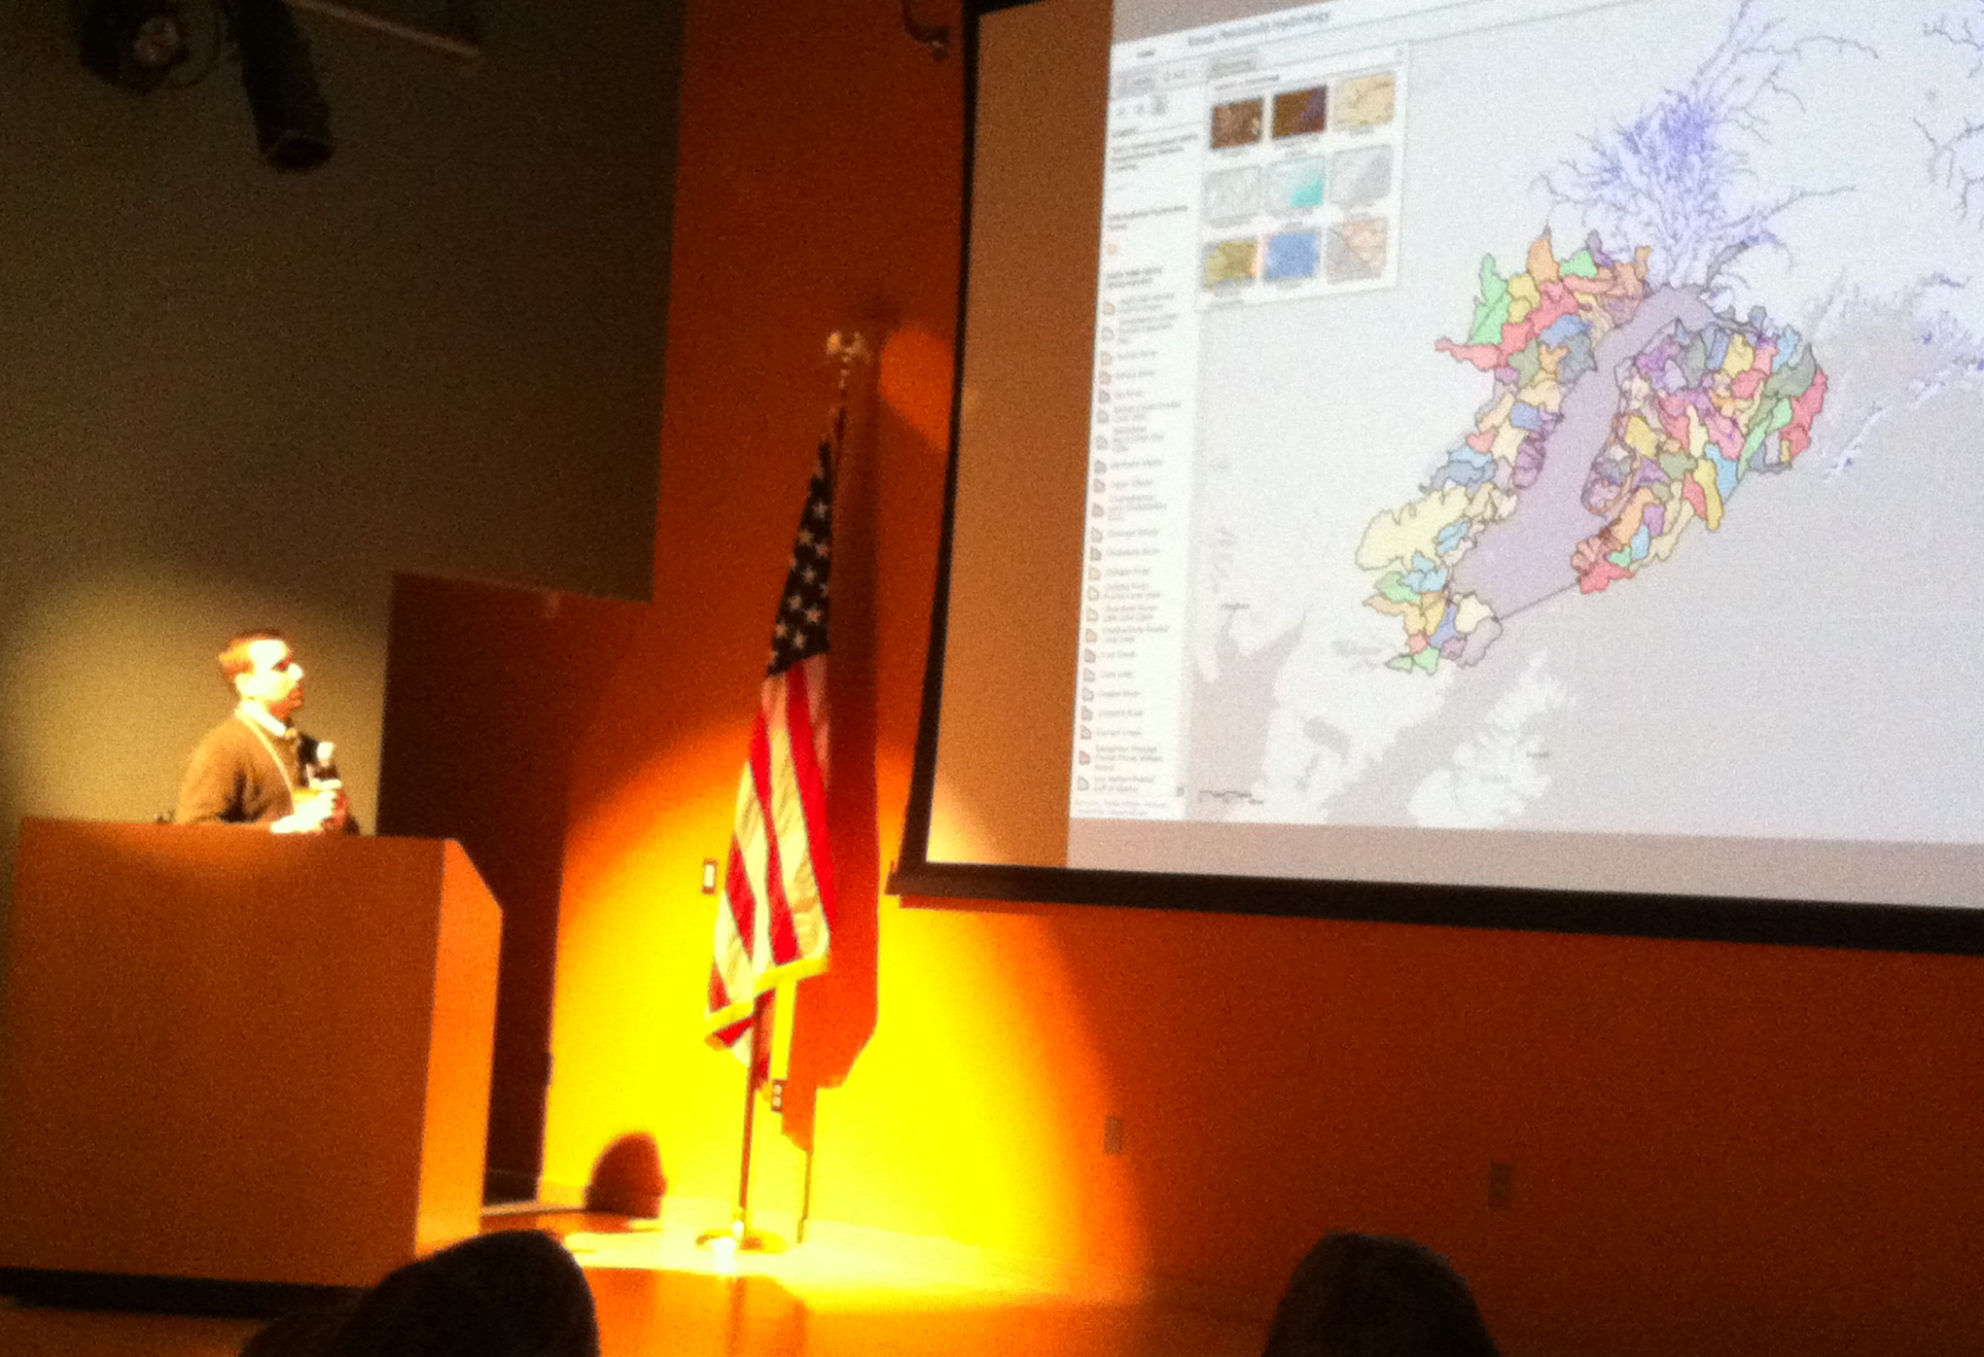
Figure 3. Presenter Branden Bornemann talks about collaborating on hydrological datasets at the first Kenai Peninsula Fish Habitat Partnership Science Symposium.

In addition to research presentations, the Partnership introduced the new Conservation Action Plan (CAP) for prioritizing Kenai Peninsula habitat concerns and restoration efforts for freshwater and marine habitats. After the presentation attendees got together in small working groups for a variety of topics to flush out questions and ideas the KPFHP should address in the final CAP. Information gained from this session has proved extremely useful for the KPFHP with finalizing the CAP.

Another activity the Science Symposium hosted was a round of table topics. Groups discussed topics including ATV use, invasive species, and fish passages (Figure 4). This was a way to share ideas on topics that are or should be addressed on the Kenai Peninsula.

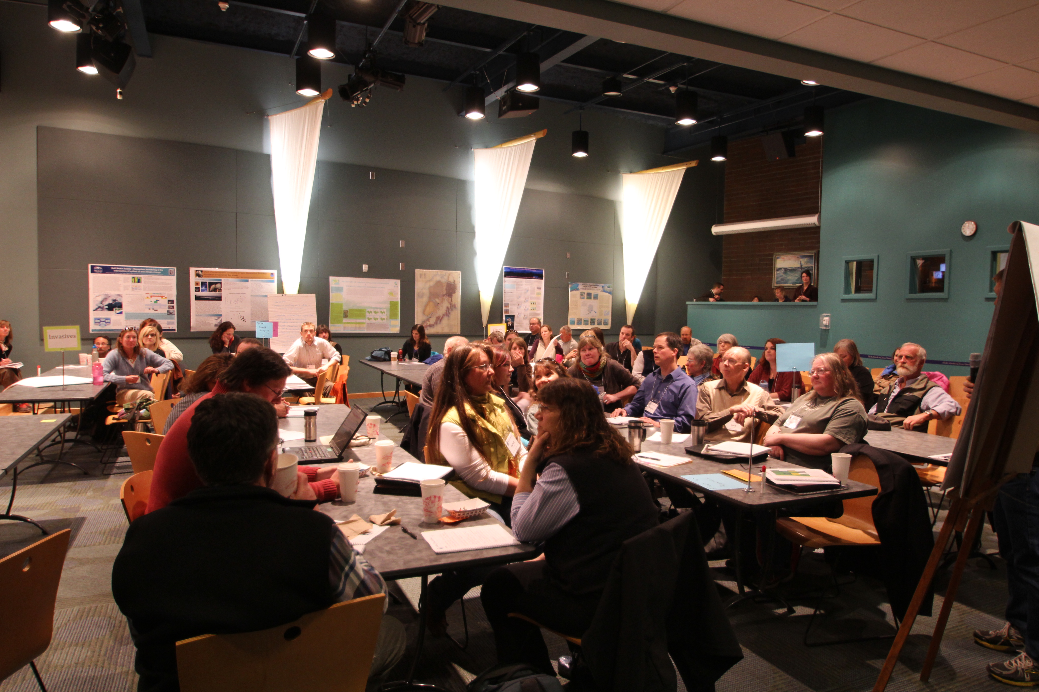
Figure 4. Symposium attendees break into groups to discuss topics that they feel should be addressed on the Kenai Peninsula.

Survey Results
Overall, the Science Symposium was well received by all respondents to the survey we created (Figure 5).

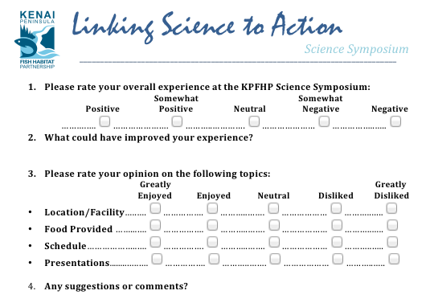
Figure 5. Survey given to participants at the first Kenai Peninsula Fish Habitat Partnership Science Symposium, Spring 2013.

100% of respondents had a positive or somewhat positive experience at the symposium (Figure 6). We also asked their opinion on the location/facility, food provided, and schedule. For all three categories, 95% of respondents greatly enjoyed or enjoyed the item of question while the other 5% were neutral on the topic. 92% of respondents greatly enjoyed or enjoyed the presentations with 8% remaining neutral.

Figure 6. Attendees rate their experience at the first Kenai Peninsula Fish Habitat Partnership Science Symposium, Spring 2013.

The great majority of comments were very complementary. Attendees enjoyed themselves and especially liked the networking opportunities provided. They also enjoyed the table topics and tidbit sharing throughout the symposium. Any negative comments pointed to the room getting too cold, uncomfortable chairs, or lack of internet access in the building; little to do with the actual content of the symposium and more so with the location we selected.

Conclusion
The first Kenai Peninsula Fish Habitat Partnership Science Symposium proved to be a huge success with a wealth of information being shared regarding research and conservation practices occurring on the peninsula. It is our hope that this event spurs collaboration and reduces duplication of efforts. The information shared during this symposium will help to direct the needs of science on the Kenai Peninsula along with the goals of the Kenai Peninsula Fish Habitat Partnership Conservation Action Plan.

